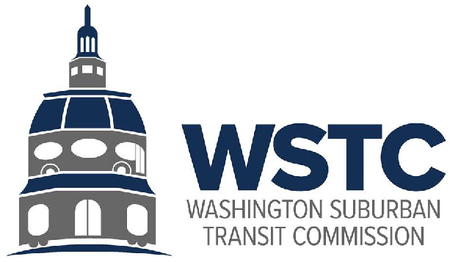

**Michael Goldman**

CHAIR

**Donald G. Drummer**

VICE CHAIR

**Eric Olson**

SECRETARY-TREASURER

**Tuesday, March 26, 2024**

**9:30 AM**

**WSTC Bi-Annual Commissioners Meeting Minutes**

|  |
| --- |
| **Commissioners in Attendance** |
| Mr. Mike Goldman, Chair |
| Mr. Donald Drummer |
| Mr. Eric Olson |
| Mr. Tom Hucker |
| Mr. Raymond J. Briscuso, Jr |
| Mr. Drew Morrison, MDOT as Secretary’s Designee |
| **Staff in Attendance** |
| Mr. Drew Morrison, Acting- Director, Washington Area Transit Office |
| Ms. Tammy Cooper |
| Mr. Sara LeBarron |
| **County Representatives in Attendance** |
| Ms. Semia Hackett, Prince George’s County |
| Mr. Gary Erenrich, Montgomery County |
| Ms. Haley Peckett, Montgomery County, Deputy Director |
| **Public in Attendance** |
| Mr. Bill Orleans |

# Call to Order

# Chair Goldman called the meeting to order at 9:37 AM and a quorum was met.

1. **Consent Calendar**
2. A motion to approve the agenda was presented by Chair Goldman and approved unanimously by attending commissioners.
3. A motion to approve the minutes from the December 12, 2023, Bi-Annual Business Meeting was presented by Chair Goldman and approved unanimously by attending commissioners.

# Public Comment

# Mr. Bill Orleans expressed his concern regarding the cancellation of the public forum.

# Amendment to WSTC By-Laws

# Mr. Drew Morrison discussed amending the By- Laws in order to alternate four-year terms between Montgomery and Prince George’s County for the permanent Director.

# A footnote following “relevant year” would be provided to read:

# As of March 2024, the next rotation of the Commissioners would occur on July 1st, 2025, with the four-year rotation beginning thereafter, as the current Commission appointee to the WMATA Board of Directors is a Prince George’s County resident, whose term of service began July 1st, 2021, such that the term of the succeeding Montgomery County resident as the Commission appointee to the WMATA Board shall begin on July 1, 2025.

# A motion was made by Mr. Briscuso to update the amendment and seconded by Mr. Olson; the motion was unanimously approved by all attending commissioners.

# FY2025 Proposed Budget

# Ms. Sara LeBarron reviewed WSTC’s proposed FY2025 budget in the amount of $542,955. The personnel costs were an 8% increase over the FY2024 approved budget. The salary for the vacant transit analyst was adjusted to be in line with current MDOT salary range in addition to the assumption of a 3% increase in salary for the WSTC staff January 1, 2024 and January 1, 2025. The Metro Joint Study Fund was approved during the December 2023 Semi-Annual Commissioners meeting and added to the proposed FY2025 budget in the total amount of $21,000. The overall budget increase was 9% with the addition of the Joint Study Fund, without the Joint Study Fund the increase would be a 5% increase.

# Mr. Thomas Graham made a motion to approve the WSTC FY25 budget, and seconded by Mr. Don Drummer, the motion was unanimously approved by all attending commissioners.

# WMATA FY2025 Fiscal Cliff and Beyond

1. Final Budget Updates - Mr. Drew Morrison confirmed legislation continues to move forward in Annapolis regarding the additional subsidy and removal of the 3% cap. The legislation includes a requirement that the Purple Line be on the Metrorail map and that the Board Chair rotate among the jurisdictions.
2. MWCOG Update - The Council of Governments is beginning to work with WMATA on scoping out a regional study to talk about the future of WMATA’s funding and to address some of the sustainability challenges for the long-term. That is also combined with what can be done for the capital budget, which is going to become an issue in the next few fiscal years. More information to come from the council of governments in the coming weeks regarding the timing and nature of their work. Mr. Rogers or Mr. Morrison will come back to the Commission to talk about what timing would make sense to participate successfully in that regional conversation.

# WSTC Update

# Update on WSTC Internal Matters

# Mr. Jonathan Rogers will become the permanent director for the Washington Area Transit Office. Mr. Rogers is currently the Neighborhood Planning Manager for the Washington, D.C. Department of Transportation. Mr. Drew Morrison and Assistant Secretary Joe McAndrew will continue to be engaged alongside Mr. Rogers to advance important work at WSTC.

# Policy and Program Updates

# Joint Study Fund Project Update – Although a little behind, WSTC is working on advancing the RFP for the Commission. The Commission will continue to be updated on the status of the Metro Access Study.

# Better Bus Network – Major regional initiative for the future of local transit and WMATA, what the funding looks like and how that supports the bus service overall.

# County Conversation

# Montgomery County - Ms. Haley Peckett discussed the Great Seneca Transit Network, where new bus routes will be added, with upgraded stops, as well as some dedicated lanes for this area to support economic development and access.

# Ms. Peckett commended Gary Erenrich, a great advocate and champion to help us get 4.2 lane miles of red bus length added to University Boulevard that just opened last month. This road has the highest ridership baseline in Maryland and the third or fourth in the entire Metro system. There are about 9,000 plus riders a day on that route.

# Prince George’s County – Ms. Semia Hackett, announced that Prince George’s County completed the zero-emissions bus implementation plan, expecting to launch that plan or release the full plan in the coming weeks. Conceptual design has been completed, and an order of magnitude cost estimates for microgrid implementation at the main bus garage. Planning is ongoing for the service change that is scheduled to be implemented in late May. In addition to the service changes, new service zones with the micro transit service called the PGC Link will be launched.

# Good Of the Order

# Resolution – The Commission unanimously approved a motion to have a formal resolution of appreciation for Mr. Drew Morrison’s role as Acting Director for the Washington Suburban Transit Office.

# Closing Remarks

# The meeting was adjourned at 10:37am

# 