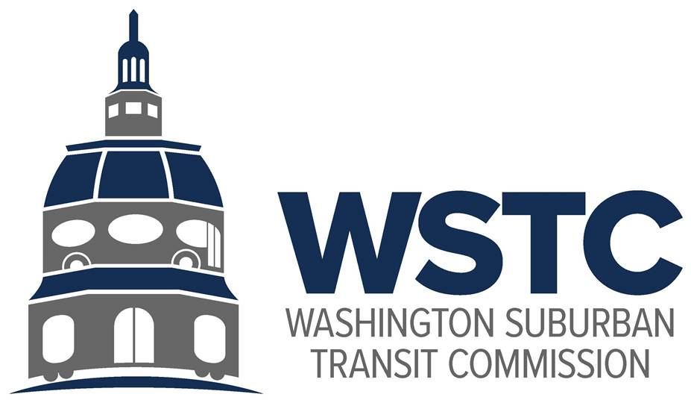

**MICHAEL GOLDMAN**

CHAIR

**DONALD G. DRUMMER**

VICE CHAIR

**COUNCILMEMBER ERIC OLSON**

SECRETARY-TREASURER

March 26, 2024 Resolution 03-2024

Board Resolution of Washington Suburban Transit Commission Indicating Appreciation of Acting Director Mr. Drew Morrison

WHEREAS, Washington Suburban Transit Commission desires to provide acknowledgement of Mr. Drew Morrison’s dedication and professionalism since stepping into the role as Acting Director in July 2023, be it RESOLVED that:

The Commission commends and thanks Mr. Drew Morrison for his service to the Commission as Acting Director of the Washington Suburban Transit Office and serving in this role with professionalism and responsiveness. The Commission is unanimous in its appreciation for Mr. Morrison’s work and dedication.