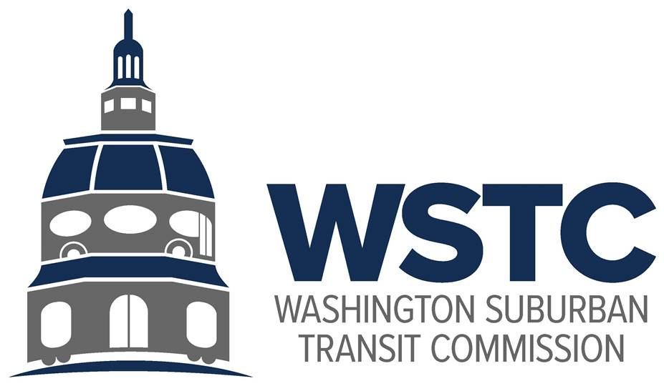

**MICHAEL GOLDMAN**

CHAIR

**DONALD G. DRUMMER**

VICE CHAIR

**COUNCILMEMBER ERIC OLSON**

SECRETARY-TREASURER

**Washington Suburban Transit Commission (WSTC)**

**Compliance Report:** Lobbying

**Reporting Period:** Calendar Year 2023

Following the 2020 Regular Session of the Maryland General Assembly, House Bill 370 was

Enacted on May 8, 2020, as Chapter 185 – Bicounty Commissions – Annual Reports – Conflicts of Interest and Lobbying – PG/MC 102-20 (hereafter Chapter 185, or Ch. 185) under Article ii, §

17(c) of the Maryland Constitution. Chapter 185 requires each Maryland bicounty Commission

to produce an annual report on lobbying before the bicounty commission and regulation of that lobbying during the previous calendar year, submit the report to the governing body of each county in which the bicounty commission operates, and publishes the report on the bicounty Commission’s website.

Lobbying Before the Washington Suburban Transit Commission

In Calendar Year 2023, the Washington Suburban Transit commission (WSTC, or the Commission) as a body was not lobbied or approached with the intent of lobbying by an identified, regulated lobbyist or lobbying firm registered with the Maryland State Ethics Commission to discuss transportation or transit issues or topics in the Transit District (Montgomery and Prince George’s Counties).

Lobbying of Commissioners

Commissioners were asked to report whether they were registered with the Maryland State Ethics Commission as a regulated lobbyist, and/or if they had been lobbied or approached with the intent or lobbying by an identified, regulated lobbyist or lobbying firm registered with the Maryland State Ethics Commission in Calendar Year 2023 to discuss transportation or transit issues or topics in the Transit District as a result of their official role as a Commissioner of the WSTC. No Commissioners responded that they were registered, regulated lobbyists in Calendar Year 2023. Likewise, no Commissioners reported that they were lobbied or approached by a registered, regulated lobbyist or lobbying firm as a result of their position on the Commission in Calendar Year 2023.

The Commissioners of record of the Washington Suburban Transit Commission during Calendar Year 2023 included:

* Mr. Donald Drummer
* Mr. Michael Goldman
* Mr. Thomas Graham
* Hon. Eric Olson
* Mr. Tom Hucker
* Mr. Raymond J. Briscuso, Jr.
* Secretary of Transportation Paul Wiedefeld

Questions

Any questions, comments, or requests for additional information should be directed to:

Drew Morrison

Acting Director, Washington Area Transit Office

Maryland Department of Transportation

8400 Corporate Drive

Suite 120

Landover, MD 20785

Office: (410)-865-1093

Mobile: (301)-602-0595

Email: dmorrison5@mdot.maryland.gov