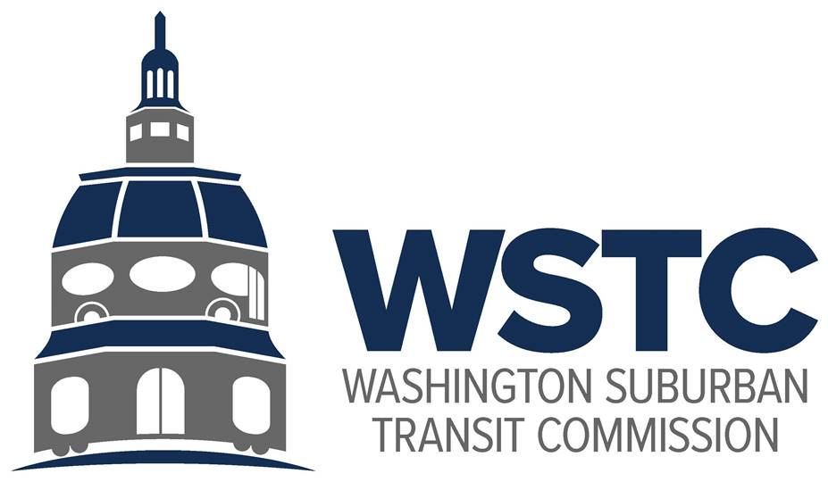

**MICHAEL GOLDMAN**

CHAIR

**DONALD G. DRUMMER**

VICE CHAIR

**COUNCILMEMBER ERIC OLSON**

SECRETARY-TREASURER

**Washington Suburban Transit Commission (WSTC)**

**Compliance Report:** Conflict of Interest

**Reporting Period:** Calendar Year 2023

Following the 2020 Regular Session of the Maryland General Assembly, House Bill 370 was

Enacted on May 8, 2020, as Chapter 185 – Bicounty Commissions – Annual Reports – Conflicts of Interest and Lobby – PG/MC 102-20 (hereafter Chapter 185, or Ch. 185) under Article ii, §

17© of the Maryland Constitution. Chapter 185 requires each Maryland bicounty Commission

to produce an annual report on conflict-of-interest issues and regulation during the previous

Calendar year, submit the report to the governing body of each county in which the bicounty

Commission operates and publishes the report on the bicounty Commission’s website.

WSTC Conflict of Interest Policy

Regulations governing conflict of interest for the Washington Suburban Transit Commission

(WSTC, or the Commission) are specified in the enabling legislation which established the

Commission. Equivalent language is included in the county code of both Montgomery and Prince

George’s Counties (the district).

10. Conflicts of Interest

1. No commissioner, nor any other officer, employee, agent or consultant, shall have any interest in any person or company engaged in the business of provide public transportation in the district or within the metropolitan area in which the district is located, or in the manufacture or sale of passenger transportation equipment or facilities.
2. No commissioner nor any agent, officer, employee, or consultant thereof, shall contract with the district or be interested in, either directly or indirectly, any contract with the district or in the sale of any property, either real or personal, to the district.
3. Any violation of this provision shall be a misdemeanor and punished as provided by law.
4. All commissioners are public officials as defined under the Maryland Public Ethics Law and are subject to the restrictions and requirements set forth in Title 15 of the State of Government Article of the Annotated Code of Maryland, as amended and supplemented.

(Laws 1965, Ch. 870, Sec. 1; Laws 1963, Sec. 83A-10; Ch. 433, Laws of Md., 2012)

Compliance

* Financial Disclosure Statements

As required by public officials under Title 15 of the State Government Article, the Commissioners of the WSTC must submit by April 30 a Financial Disclosure Statement with the Maryland State Ethics Commission. As of April 29, 2024, all Commissioners have successfully submitted Financial Disclosure Statements.

The Commissioners of record for the Washington Suburban Transit Commission during Calendar Year 2023 included:

* Mr. Donald Drummer
* Mr. Michael Goldman
* Mr. Thomas Graham
* Hon. Eric Olson
* Mr. Tom Hucker
* Mr. Raymond J. Briscuso, Jr.
* Secretary of Transportation Paul Wiedefeld
* Vendors

The following list includes all vendors with which the Commission conducted routine business during Calendar year 2023. This list was provided to WSTC Commissioners for use in completing their Financial Disclosure Statements:

* Comcast
* Corporate Payroll Services
* C.N.A. Insurance/NFP
* Empower Retirement
* Garden City Investors, LLC
* GoDaddy.com
* INDEED
* Keys & Associates, P.C.
* LinkedIn
* M&T Bank
* Montgomery County Government
* Patch.com
* PDC METRO EAST, LLC
* Staples
* Verizon Communications, Inc.
* VistaPrint.com
* Washington Post
* Zip Moving & Storage
* Zip Recruiter
* Recusals

In the event that a commissioner held an interest (personal or property) in an outside organization which would create a conflict of interest in their ability to discuss or determine Commission policy, or to approve or authorize a contract or grant, the Commissioner(s) would be expected to self-identify the potential conflict and recuse themselves from the discussion and/or vote.

In Calendar Year 2023, there were no recusals on action items before the Commission as a result of self- or otherwise identified conflicts of interest.

Questions

Any questions, comments, or requests for additional information should be directed to:

Drew Morrison

Acting Director, Washington Area Transit Office

Maryland Department of Transportation

8400 Corporate Drive

Suite 120

Landover, MD 20785

Office: (410)-865-1093

Mobile: (301)-602-0595

Email: dmorrison5@mdot.maryland.gov