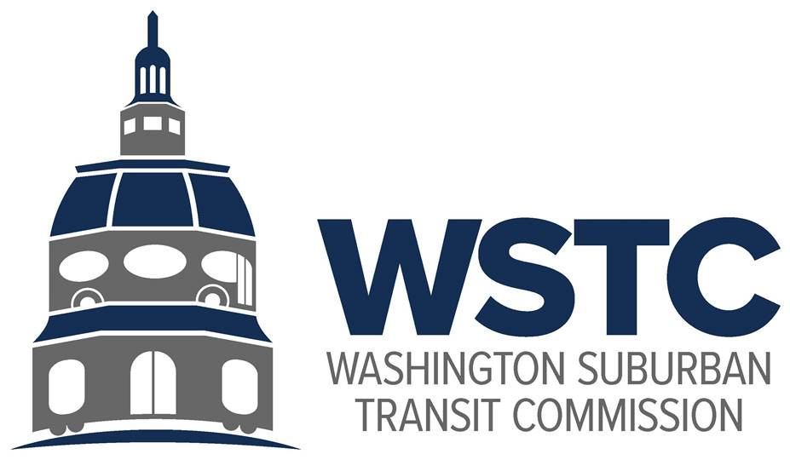

**MICHAEL GOLDMAN**

CHAIR

**DONALD DRUMMER**

VICE CHAIR

**COUNCILMEMBER ERIC OLSON**

SECRETARY-TREASURER

**Tuesday, March 26, 2024**

**9:30 AM**

**March 2024 Bi-Annual Meeting**

1. **Call to Order/Introductions (Chair)**
2. **Consent Calendar (Chair) – ACTION ITEM**
   1. Approval of the Agenda
   2. Approval of the December 2023 Meeting Minutes
3. **Public Comment (Chair)**
   1. Comments from the public pre-submitted to [wstcofficial@gmail.com](mailto:wstcofficial@gmail.com) by the close of business Monday, March 25, 2024 will be read into the record of the meeting.
4. **Amendment to WSTC By-Laws (Chair)**a. Review and Approval of Second WSTC By-Law Amendment – **ACTION ITEM**
5. **FY2025 Proposed Budget (Financial Analyst, WSTC) – ACTION ITEM**
6. **WMATA FY2025 Fiscal Cliff and Beyond (Chair)**
   1. Final Budget Updates
   2. MWCOG Update
7. **WSTC Update (Acting Director, Washington Area Transit Office)**
   1. Update on WSTC Internal Matters
      1. New Director
   2. Policy and Program Updates (FY2024 Work Plan)
      1. Joint Study Fund Project Update
      2. Better Bus Network
8. **County Conversation (Commissioners; County Representatives)**
   1. Prince George’s County
   2. Montgomery County
9. **Good of the Order (Chair)**
10. **Closing Remarks (Acting Director, Washington Area Transit Office)**