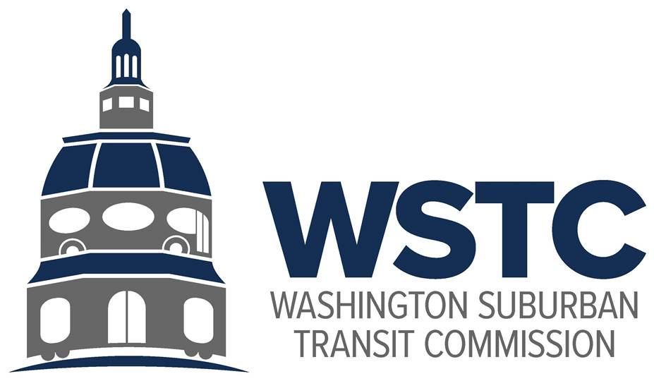

**MICHAEL GOLDMAN**

CHAIR

**DONALD G. DRUMMER**

VICE CHAIR

**COUNCILMEMBER ERIC OLSON**

SECRETARY-TREASURER

**WSTC Meeting  
December 12, 2023**

**Agenda Item 6.   
Joint Study Fund**

**Action Item**

**Overview**As identified in the FY2024 Work Plan, MDOT/WSTC staff have been working collaboratively with the Counties to use the existing WSTC fund balance to create a Joint Study Fund to support consultant resources for evaluating key WMATA policy issues. WSTC staff have estimated that approximately $100,000 is available for this purpose for FY2024.

Staff received concurrence from County leadership to focus the first effort of the Study Fund on MetroAccess policy. As the Commissioners are aware, Maryland pays for 60-65% of all MetroAccess costs. This service is critical for people with disabilities but faces continued cost growth into the future. Through the current Abilities-Ride program, WMATA has had success in working with MetroAccess customers to identify transportation options that meet their needs and are lower cost to provide.

This study will evaluate the current landscape of MetroAccess and Medicaid Transportation in Montgomery and Prince George’s County, identify the drivers of MetroAccess usage, evaluate what regional and national peer jurisdictions are doing to meet the need for paratransit in a sustainable way, and lay out a roadmap for Maryland’s coordination with WMATA, the Counties, and local transportation providers.

**Action Requested**

The Commission approves the creation of a Joint Study Fund.

The Commission approves an amendment to the FY2024 Budget to allocate $100,000 of fund balance to the Joint Study Fund.

The Commission directs staff to coordinate with Montgomery and Prince George’s Counties to finalize the Scope of Work for the Maryland MetroAccess Strategy Study and to release a Request for Proposals in early calendar year 2024.

**Staff Recommendation**

Staff recommends approval.

**DRAFT Scope of Work**

**Maryland MetroAccess Strategy Study**

**Overview**

MetroAccess, and transportation for people with disabilities more generally, is a critical piece of the public transit landscape in the Metro Washington region. As Maryland works to center equity in transportation, Maryland is committed to providing quality transit service to people with disabilities. At the same time, Maryland represents a disproportionate portion of total MetroAccess costs – well over half of total costs. As a result, understanding how to provide transportation for people with disabilities while managing the long-term cost curve is a critical need.

Previous and ongoing efforts have looked at MetroAccess in the region and in Maryland and piloted different approaches. It is timely to develop a clearer roadmap for the future.

This Study will evaluate the existing landscape of MetroAccess, Medicaid Transportation, and other resources for people with disabilities. It will evaluate how local peers, through Abilities-Ride or other regional programs, have been able to provide paratransit in lower cost ways. It will also evaluate how national peers have done the same.

The Study will then turn to opportunities for innovation in Maryland. Informed by past efforts, such as CAPS and TransportDC, the Study will look at pathways for resources and for program design that Maryland should advance in concert with WMATA and regional partners. This Study will position WMATA and Maryland well for further evaluation and implementation in upcoming fiscal years.

**Scope of Services**

Task 1. Landscape and Cost Driver Analysis

In this task, the Consultant will provide a landscape analysis to understand how Medicaid Transportation and paratransit are provided in Montgomery and Prince George’s and to understand the drivers of costs to the counties and to Maryland. The Consultant will review past efforts around CAPS and TransportDC and understand current planning efforts at WMATA on MetroAccess, as well as the current status of the Transportation Service Improvement Fund (TSIF) in Montgomery County.

The Consultant will provide information, as possible, about where and how Marylanders are using MetroAccess and Medicaid Transportation in the region, to better understand service and cost drivers.

The Consultant will develop a brief memorandum, to be included as the first section of the final report, that outlines the findings of this task.

Task 2. Peer Review

In light of the major drivers of demand and cost, the Consultant will review how peer agencies in the DC region and throughout the country are managing the need to provide quality service for people with disabilities with the need for sustainable funding strategies.

The Consultant should review Marylanders’ use of the Abilities-Ride service and similar other efforts across the region and country.

Task 3. Strategy Roadmap and Final Report

Based on the findings of Task 1 and Task 2, and informed by targeted stakeholder engagement, the Consultant should propose a strategy roadmap for Maryland to consider how it can further advance a regional conversation about the transformation of MetroAccess.

This roadmap should be integrated into a brief (10-15 page) report bringing together the findings and recommendations of the three tasks of the study.