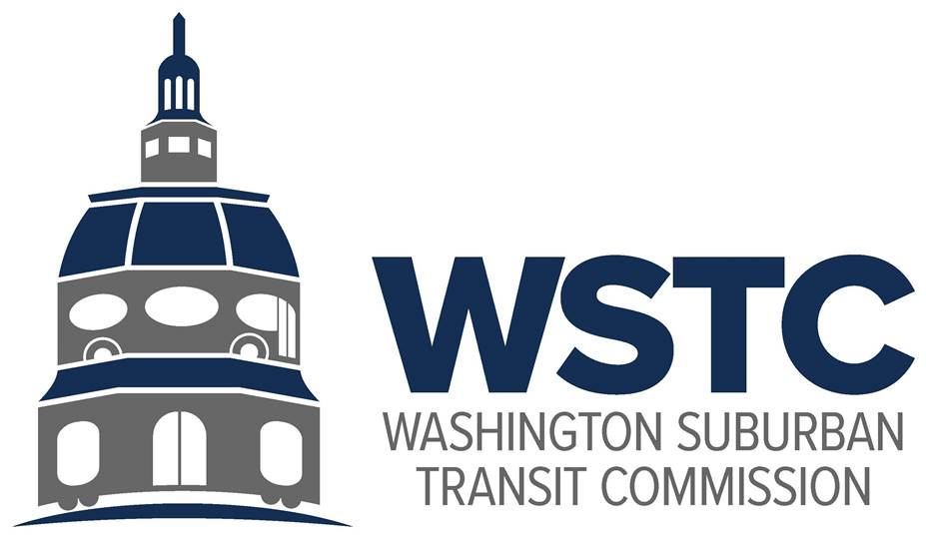

**MICHAEL GOLDMAN**

CHAIR

**DONALD G. DRUMMER**

VICE CHAIR

**COUNCILMEMBER ERIC OLSON**

SECRETARY-TREASURER

**WSTC Meeting  
December 12, 2023**

**Agenda Item 5.   
FY2023 Audit**

**Action Item**

**Overview**In the December 12, 2023 meeting, Sara LeBarron, Financial Analyst, will summarize the FY2023 audit findings. The FY2023 audit was conducted by Key and Associates.

**Action Requested**

The Commission receives and accepts the findings of the FY2023 audit. The Commission directs staff to post the audit to the WSTC website.

**Staff Recommendation**

Staff recommends approval.