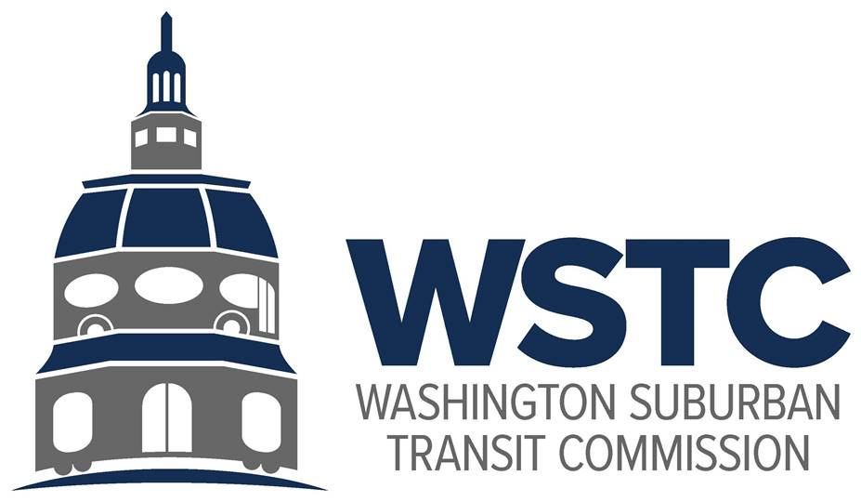

**MICHAEL GOLDMAN**

CHAIR

**DONALD G. DRUMMER**

VICE CHAIR

**COUNCILMEMBER ERIC OLSON**

SECRETARY-TREASURER

**Tuesday, December 12, 2023**

**9:30 AM**

**FY 2024 Mid-Year Business Meeting**

**AGENDA**

1. **Call to Order/Introductions (Chair)**
2. **Approval of the Agenda (Chair)**
3. **Approval of the September Meeting Minutes (Chair) - ACTION ITEM**
4. **Public Comment (Chair)**
   1. Comments from the public pre-submitted to [wstcofficial@gmail.com](mailto:wstcofficial@gmail.com) by the close of business Monday, December 11, 2023 will be read into the record of the meeting.
5. **FY2023 Audit (Key & Associates / Financial Analyst, WSTC)**a. Review and approval of FY2023 Audit – **ACTION ITEM**
6. **WMATA Joint Study Fund (Director, Washington Area Transit Office)**
   1. Proposed draft scope of work for FY2024 Study Fund project – **ACTION ITEM**
7. **FY2025 Proposed Budget (Financial Analyst, WSTC)**
8. **Amendment to WSTC By-Laws (Chair)**
   1. MDOT Memorandum on Board of Directors terms
   2. Consideration of term length for State of Maryland Permanent Director who is not the Secretary of Transportation
   3. Proposed changes to WSTC By-Laws regarding WMATA Board Directors – **ACTION ITEM**
9. **WMATA FY2025 Fiscal Cliff (Chair)**
   1. MDOT update on FY2025 Budget
   2. Consideration of WSTC Public Forum
10. **WSTC Update (Director, Washington Area Transit Office)**
    1. Update on WSTC internal matters
       1. Office move
       2. Transit analyst position
    2. Policy and Program Updates (FY2024 Work Plan)
       1. PG/MC 103-24 legislation
       2. MWCOG convenings
       3. County engagement
       4. Better Bus Network
       5. Bus Subsidy Formula updates
11. **County Conversation (Commissioners; County Representatives)**
    1. Prince George’s County
    2. Montgomery County
12. **Good of the Order (Chair)**
13. **Closing Remarks (Director, Washington Area Transit Office)**
    1. New meeting cadence proposal (March and September)