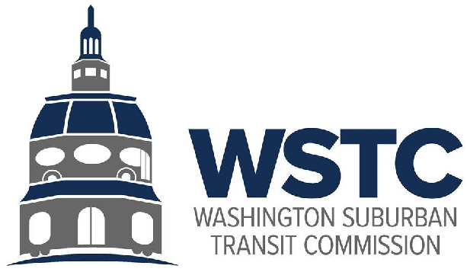

MICHAEL GOLDMAN
CHAIR
DONALD DRUMMER
VICE CHAIR
COUNCILMEMBER ERIC OLSON
SECRETARY-TREASURER

Wednesday, September 20, 2023
9:30 AM

September 2023 Bi-Annual Meeting AGENDA

- Call to Order/Introductions (Chair)

- Approval of the Agenda (Chair)

- Recognition of Board Actions (Chair)
  - Budget
  - Officers
  - Minutes

- Public Comment (Chair)
  - Comments from the public pre-submitted to wstcofficial@gmail.com by the close of business Tuesday, September 19, 2023 will be read into the record of the meeting.

- Amendment to WSTC By-Laws (Chair)
  - Discussion of potential changes to WSTC By-Laws regarding the WMATA Permanent Director.

- WSTC Update (Acting Director, Washington Area Transit Office)
  - Update on WSTC Finances and Internal Matters
    - FY2023 End-of-Year Financial Position
    - Office Move
    - Transit Analyst Position

  - FY2024 Washington Area Transit Office / WSTC Work Program
    - Work Program Overview
    - WMATA Joint Study Fund

  - Policy and Program Updates
    - MWCOG Convenings
    - County Engagement
    - Better Bus Network
    - Secretary Wiedefeld NVTA Presentation

- County Conversation (Chair)
  - Prince George’s County
    - DPW&T Presentation
  - Montgomery County

- WMATA FY2025 Fiscal Cliff (Mr. Scott, WMATA)

- Good of the Order (Chair)

- Closing Remarks (Acting Director, Washington Area Transit Office)
  - Next Meeting

- Executive Session (Chair)

